Planning and design

Simon Fish

University of Sheffield

COM1008 – Web and Internet Technology

Contents

General Ethos 1

Site Map 1

Accessibility 1

Design Mock-Ups 1

Menu System 2

# General Ethos

The site I aim to produce requires a fine balance between being a website for children and for adults. As a company that markets to children, it is important that the company I am creating the design for also creates an experience marketable to adults, as young children do not have their own sources of income. Hence, it should be my responsibility to prioritise the products of the company in a way appealing to children, while also ensuring that relevant areas of the site are quickly accessible to adults. I have decided to name my company Lachs Games.

The logo I have created is a simplistic design in one colour only, which means I can effectively tailor it to any means – it will be easy to replicate it at a low resolution, manipulate the colours to suit accessibility needs, and use either the L or the A mascot as a logo where suitable. In fact, I intend to use the L on more adult-oriented pages, with the A mascot serving as the favicon and appearing a lot more around the site where children are concerned. If I were to animate the logo (which I do not currently plan to), it would also be far easier with a mascot of that level of simplicity.

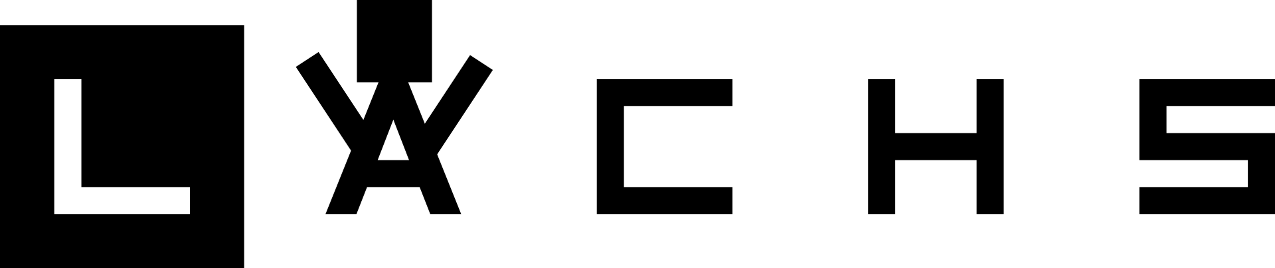

# Site Map

The site requires eight pages, all of which will be accessible from each other either by the main navigation bar or a listed site map at the bottom of the page:

* + Home
  + Our Founders
  + News
  + Recommendations
  + Our Puzzles
  + Match the Pairs
  + Contact Us
  + Accessibility Statement

It is important to note that there are an additional four placeholder pages for other games that would be on the website, but for this assignment I will create only one.

# Accessibility

I have noticed that the majority of accessibility solutions are client-side – for example, changing webpage colours for High Contrast Mode, and so on. To ensure compatibility with these extensions, I have made an effort to use images only where absolutely necessary, so that as many colours can be cleanly changed by extensions as possible.

# Design Mock-Ups

Having extensively browsed Google Fonts for something suitably similar to the logo, I will be using Press Start 2P[1] for headings, and Open Sans[2] as a clear and easily readable sans-serif font. While Press Start 2P admittedly seems like a gimmicky font to use, I feel that it is important for Lachs Games to display themselves as a company for a more modern age of board games and puzzles, hence their eager involvement in online games.

# Menu System

.

1. <https://fonts.google.com/specimen/Press+Start+2P>
2. <https://fonts.google.com/specimen/Open+Sans>